SMART RETAIL ANALYTICS FOR FASHION SALES
DESIGN DOCUMENT

Table of Contents
- Introduction
- Business Problem Statement
- Challenges and Business Impact
- Project Objectives and Scope
- Key Stakeholders
- High-Level Solution Overview
- Target Architecture
- Data Sources and Data Classification
- Data Ingestion Design
- Data Storage Design
- Data Processing & Transformation Design
- Data Model Design
- Business Logic & KPI Design
- Analytics & Visualization Design
- Orchestration, Scheduling & Monitoring
- Security & Access Control Design
- Error Handling & Data Quality Strategy
- SDLC & DevOps Strategy
- Deployment Strategy
- Modules & Timeline
- Risks, Assumptions & Dependencies
- Future Enhancements
- Conclusion

- Introduction
The fashion retail industry operates in a fast-changing environment where customer preferences, seasonal demand, and efficient inventory management play a critical role in business success. Many large fashion retailers with only offline store presence rely on basic Point-of-Sale (POS) systems to record daily sales transactions. Although these systems generate large volumes of data across multiple stores, the absence of an integrated analytics platform limits the ability to analyze sales trends, customer behavior, and operational performance in a timely and meaningful way.
In an offline retail setup, data related to sales, inventory, employees, promotions, and customers is often stored in isolated files such as spreadsheets and flat files, leading to fragmented and inconsistent reporting. Manual data handling results in frequent stockouts or overstocking, poor visibility into seasonal fashion trends, limited understanding of customer preferences, and difficulty in evaluating store-wise and employee-wise performance. Additionally, unstructured data such as product images remains unused, further reducing the potential value that data could offer to the business.
This project focuses on designing a scalable data engineering and analytics solution that consolidates structured and unstructured offline retail data into a centralized platform. By implementing automated data ingestion, transformation, and storage using modern data architecture principles, the system delivers analytics-ready datasets and interactive dashboards. The solution enables better sales forecasting, optimized inventory management, improved customer segmentation, and data-driven decision-making, ultimately enhancing operational efficiency and supporting business growth for an offline fashion retail organization.
- Business Problem Statement
The organization lacks a centralized and analytics-driven system to effectively utilize offline retail data generated from physical fashion stores. Sales, inventory, customer, and operational data captured through basic POS systems and manual processes are not integrated into a unified platform, resulting in limited business visibility and reactive decision-making. This gap prevents the organization from optimizing inventory, understanding customer behavior, and improving overall store performance.
Key Challenges
- Fragmented data across POS systems, spreadsheets, and manual records
- Lack of timely visibility into sales performance and inventory status
- Inability to analyze seasonal fashion trends and customer preferences
- Heavy dependence on manual reporting leading to errors and delays
- Underutilization of unstructured data such as product images
The project implements a centralized data engineering and analytics platform that integrates all offline retail data into a unified system. Automated ingestion pipelines consolidate structured and unstructured data into a scalable data lake, where data is cleansed, standardized, and transformed into analytics-ready datasets. A well-defined data model enables accurate analysis of sales trends, inventory movement, customer behavior, and promotion effectiveness. By replacing manual reporting with automated dashboards, the solution provides timely and reliable insights, improves inventory planning, enhances decision-making, and ensures better utilization of both structured and unstructured retail data
- Project Objectives
The primary objective of this project is to design and implement a scalable data engineering and analytics solution for an offline fashion retail organization. The solution focuses on converting raw transactional and operational data into meaningful business insights that support informed decision-making and operational efficiency.
The key objectives of the project are as follows:
• To design and implement a centralized data engineering and analytics platform for an offline fashion retail store.
• To integrate sales, inventory, customer, employee, promotion, and product image data into a unified system.
• To enable timely and accurate analysis of sales performance, inventory health, and seasonal fashion trends.
• To reduce manual reporting effort through automated data pipelines and dashboards.
• To provide business users with actionable insights through interactive Power BI reports.
• To establish a scalable and governed data architecture that supports future business growth.
- Scope of the Project
The scope of this project defines the boundaries of the analytics solution and clearly outlines what is included and excluded. The focus is on offline retail operations and batch-based data processing to support analytical reporting and business intelligence.

In Scope
- Ingestion of offline POS sales data from physical stores
- Integration of inventory, product, customer, employee, and promotion master data
- Handling of unstructured product image data and associated metadata
- Data cleansing, transformation, and modeling using a layered architecture (Bronze, Silver, Gold)
- Design of star and snowflake schemas for analytical reporting
- Development of business dashboards and KPIs using Power BI
- Implementation of data governance, security, and access control
- Batch-based data processing and scheduled pipeline orchestration
Out of Scope
- Real-time or streaming data ingestion from POS systems
- Integration with online or e-commerce sales channels
- Advanced machine learning or AI-based recommendation systems
- Customer-facing applications or mobile apps
- Third-party logistics or supplier system integrations
- Real-time fraud detection or dynamic pricing systems
- Stakeholders & RACI Matrix
Key Stakeholders
- Business Management
- Store Managers
- Inventory & Supply Chain Team
- Sales & Marketing Team
- Data Engineering Team
- Business Analysts
RACI Matrix
R = Responsible, A = Accountable, C = Consulted, I = Informed

Activity | Sponsor | Product Owner | Data Owners | Data Engineering | BI Team | Security
Project approval & funding | A | I | I | I | I | I
Requirements & KPI definition | I | A/R | C | C | C | I
Source data ownership | I | C | A/R | I | I | I
Data ingestion & processing | I | C | C | A/R | I | I
Data modeling & KPIs | I | C | C | A/R | C | I
Dashboard & reporting | I | C | C | C | A/R | I
Data quality validation | I | C | A | R | C | I
Security & access control | I | I | I | C | C | A/R
UAT & business sign-off | I | A/R | C | I | I | I
Production release | I | A | I | R | R | C

- High Level Solution Overview
The proposed solution is a centralized data engineering and analytics platform designed to transform offline fashion retail data into actionable business insights. The platform integrates data generated from physical stores, including Point-of-Sale (POS) transactions, inventory records, customer information, employee details, promotions, and unstructured product images. Data is ingested through automated pipelines and processed using a layered architecture to ensure scalability, data quality, and governance.
The solution follows a modern data lakehouse approach, where raw data is first stored in its original format and then progressively refined into clean, business-ready datasets. Structured and unstructured data are handled together, enabling a unified view of retail operations. The processed data supports analytical reporting, KPI tracking, and interactive dashboards that help business users monitor sales performance, optimize inventory, and understand customer behavior.
- Target Architecture
The target architecture is designed to support batch-based data ingestion, scalable processing, and enterprise-grade analytics for offline retail operations. It consists of multiple logical layers that ensure data reliability, traceability, and performance.
At the ingestion layer, data from offline POS systems, inventory files, and product images is collected on a scheduled basis. The raw data is stored in a centralized data lake, preserving the original format for auditing and reprocessing. The processing layer applies data cleansing, standardization, deduplication, and business transformations. Slowly Changing Dimensions (SCD) are handled to track historical changes in master data such as products, stores, and employees.
The analytics layer consists of curated fact and dimension tables modeled using star and snowflake schemas. These datasets are optimized for analytical queries and reporting. The visualization layer provides interactive dashboards and KPI reports for different stakeholders, enabling data-driven decision-making across the organization. Security, governance, and monitoring are embedded across all layers of the architecture.
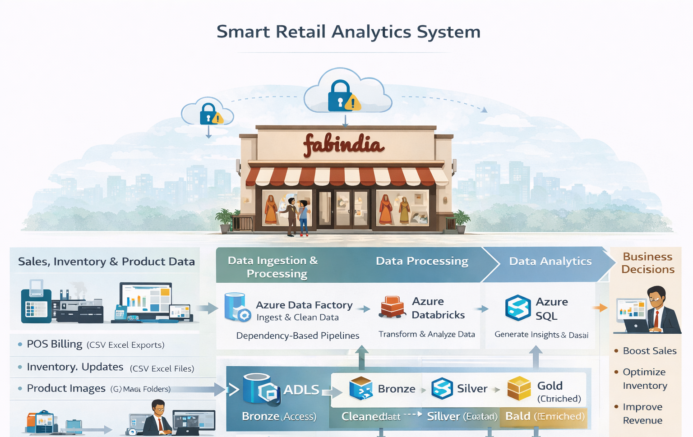

- Data Sources & Data Classification
The data used in this project is generated entirely from offline fashion retail operations and represents day-to-day business activities across physical stores. Multiple data sources are involved, producing both structured and unstructured data that must be integrated into a centralized analytics platform. Proper classification of these data sources is essential to ensure efficient processing, security, governance, and analytical usability.
Sales transaction data is sourced from Point-of-Sale (POS) systems and includes billing details such as products sold, quantities, discounts, and payment modes. Inventory and stock movement data is generated from store-level inventory systems and warehouse records, capturing product availability, replenishment, and stock adjustments. Customer and employee master data is maintained through store operations, providing information required for customer analysis and employee performance tracking. Promotion and pricing data is sourced from marketing and merchandising teams and reflects seasonal offers and discount strategies.
In addition to structured data, the project also handles unstructured data in the form of product images collected from internal product catalogs and store repositories. These images are linked with product metadata to enhance analytical reporting. Based on structure and sensitivity, data is classified into structured, semi-structured, and unstructured categories, and further categorized as internal or confidential to enforce access control, data masking, and governance policies.
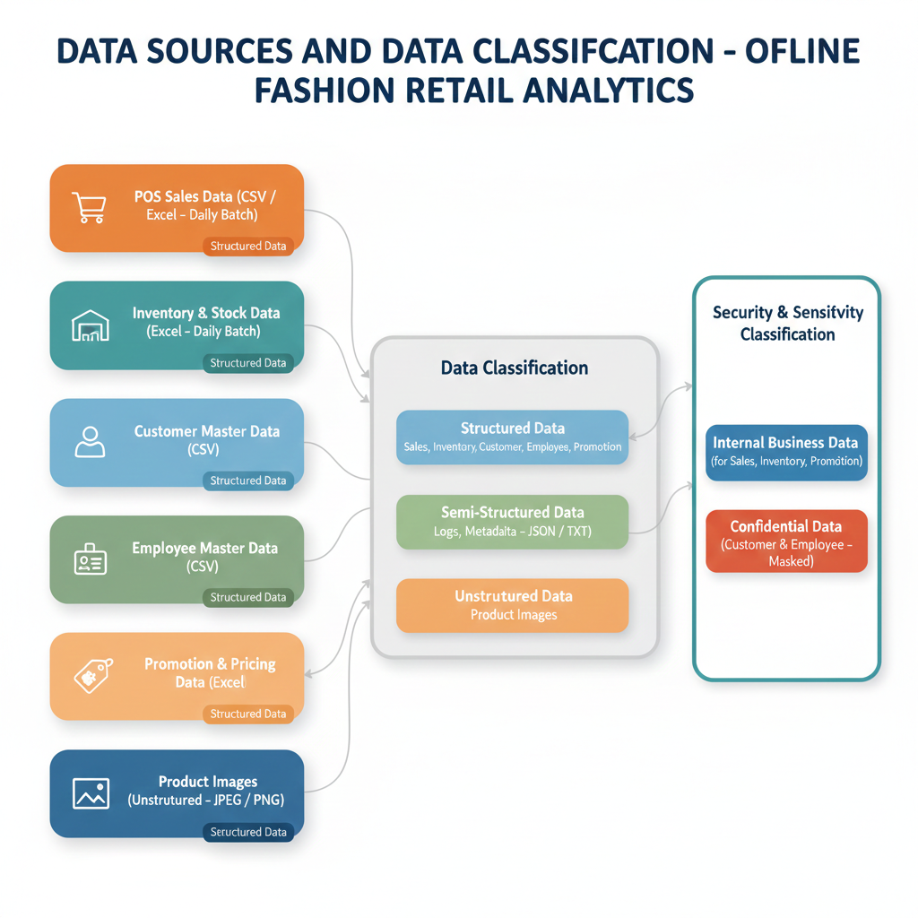
- Data Ingestion Design
The data ingestion layer collects offline retail data from multiple sources and loads it into a centralized data lake for analytics. Batch-based ingestion is used to reliably capture daily POS sales, inventory, customer, employee, and promotion data from files generated by physical stores. Basic validation and format checks are applied before storing data in the raw layer to ensure traceability and reprocessing capability.
Unstructured product images are ingested from internal repositories and stored along with metadata to enable linkage with product master data. All data is stored in its original format to support auditing, backfill, and future scalability.
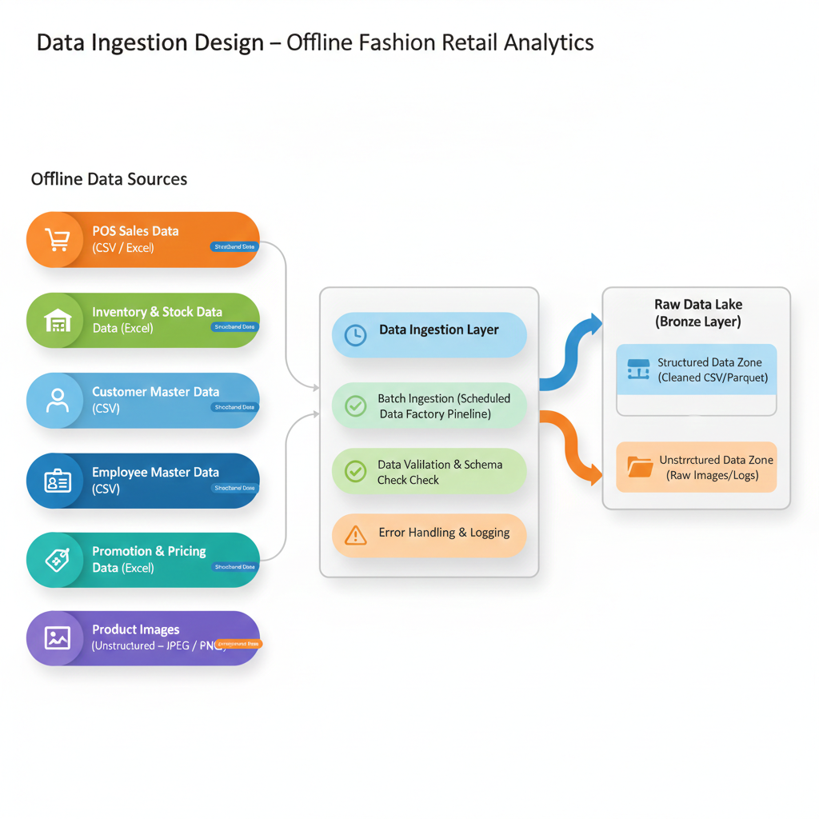
- Data Storage Design
The data storage layer is designed using a layered data lake architecture to support scalability, data quality, and analytical performance. Raw data from all sources is stored in its original format to maintain data fidelity and enable auditing and reprocessing. Processed and curated datasets are stored separately to support reporting and analytics use cases.
The storage design separates data into Bronze (raw), Silver (cleaned and standardized), and Gold (business-ready) layers. Structured data is stored in partitioned formats to optimize query performance, while unstructured product images are stored with associated metadata to enable analytical linkage. Access control and data governance policies are applied across all layers.
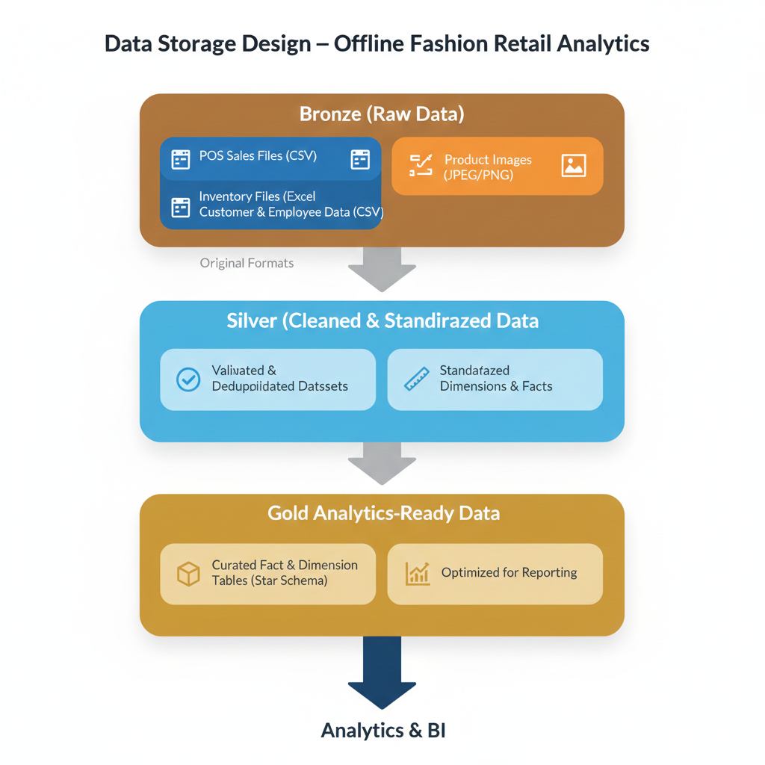
- Data Processing & Transformation Design
The data processing and transformation layer converts raw ingested data into clean, standardized, and analytics-ready datasets. Transformations are applied in stages to improve data quality, enforce business rules, and align data with analytical requirements. This layer ensures consistency across sales, inventory, customer, employee, and product data.
Key processing activities include data cleansing, null handling, deduplication, schema standardization, and enrichment using reference data. Business logic such as sales aggregation, inventory calculations, and KPI derivations is applied during transformation. Slowly Changing Dimensions (SCD Type 2) are used to track historical changes in master data. The transformed datasets are stored in curated layers for downstream reporting and analytics.
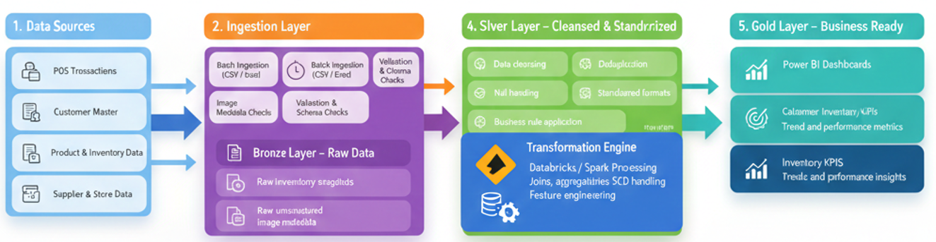

- Data Model Design
The data model follows a relational design with clearly defined primary and foreign key relationships to support analytical reporting and historical analysis. The Sales Transaction table acts as the central fact table, linking customer, product, store, and inventory master data.
Key characteristics:
- 12–15 normalized tables
- Strong referential integrity across entities
- Supports sales, inventory, and customer KPIs
- Optimized for analytical and reporting queries
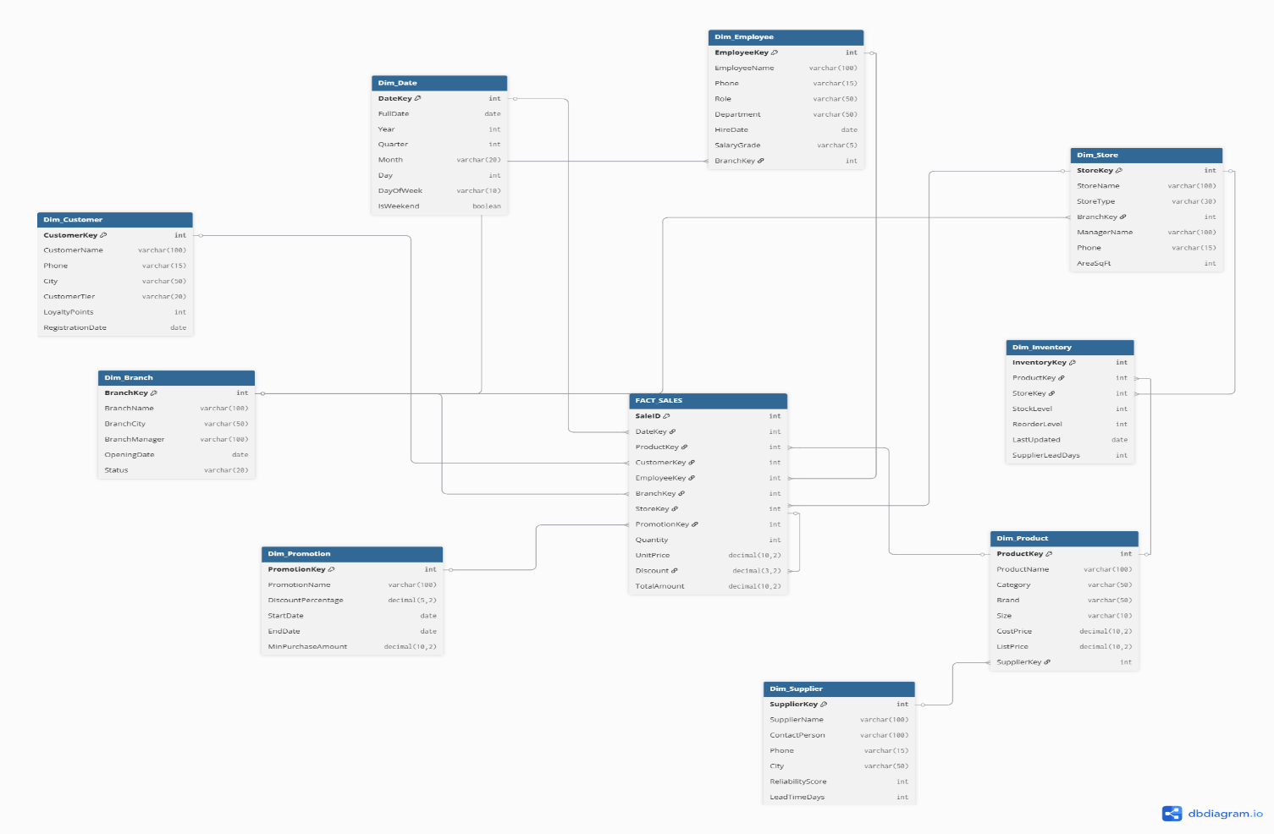

- Business Logic & KPI Design
Business logic is applied during data transformation to convert raw operational data into meaningful business KPIs. These KPIs enable store managers and leadership to monitor performance, profitability, and customer behavior.
Key KPIs include:
- Total sales and revenue per store
- Average order value (AOV)
- Product sell-through rate
- Inventory turnover ratio
- Customer purchase frequency
- Category-wise sales contribution
- Analytics & Visualization Design
Power BI is used to visualize curated datasets and deliver insights to both operational and management users. Dashboards are designed with role-based views for clarity and decision-making.
Dashboards provide:
- Store-wise sales performance
- Product and category trends
- Inventory availability and aging
- Customer purchase behavior analysis
- Orchestration, Scheduling & Monitoring
Data pipelines are centrally managed using Azure Data Factory to ensure smooth and reliable execution. Batch processes are scheduled based on business needs, and monitoring mechanisms are in place to quickly identify and address failures.
Includes:
- Scheduled batch pipeline execution
- Dependency-based orchestration
- Pipeline and job monitoring
- Alerts for failures and data delays
- Security & Access Control Design
Data security is enforced across all layers of the platform to safeguard sensitive retail and customer information. Access controls are applied based on user roles and responsibilities.
Key measures:
- Role-Based Access Control (RBAC)
- Restricted access to customer and pricing data
- Controlled access to storage and compute resources
- Error Handling & Data Quality Strategy
To ensure trustworthy analytics, the solution incorporates proactive data quality checks and structured error-handling mechanisms throughout the data pipeline.
Strategies include:
- Retry logic in ingestion pipelines
- Centralized logging and error tracking
- Data validation and completeness checks
- Isolation of invalid or incomplete records
- SDLC & DevOps Strategy
The development lifecycle follows a structured SDLC approach supported by DevOps practices. This enables controlled development, testing, and deployment across environments.

Approach includes:
- Version control using Git
- CI/CD pipelines for ADF, Databricks, and Power BI
- Environment separation (Dev, Test, Prod)
- Controlled releases with rollback support
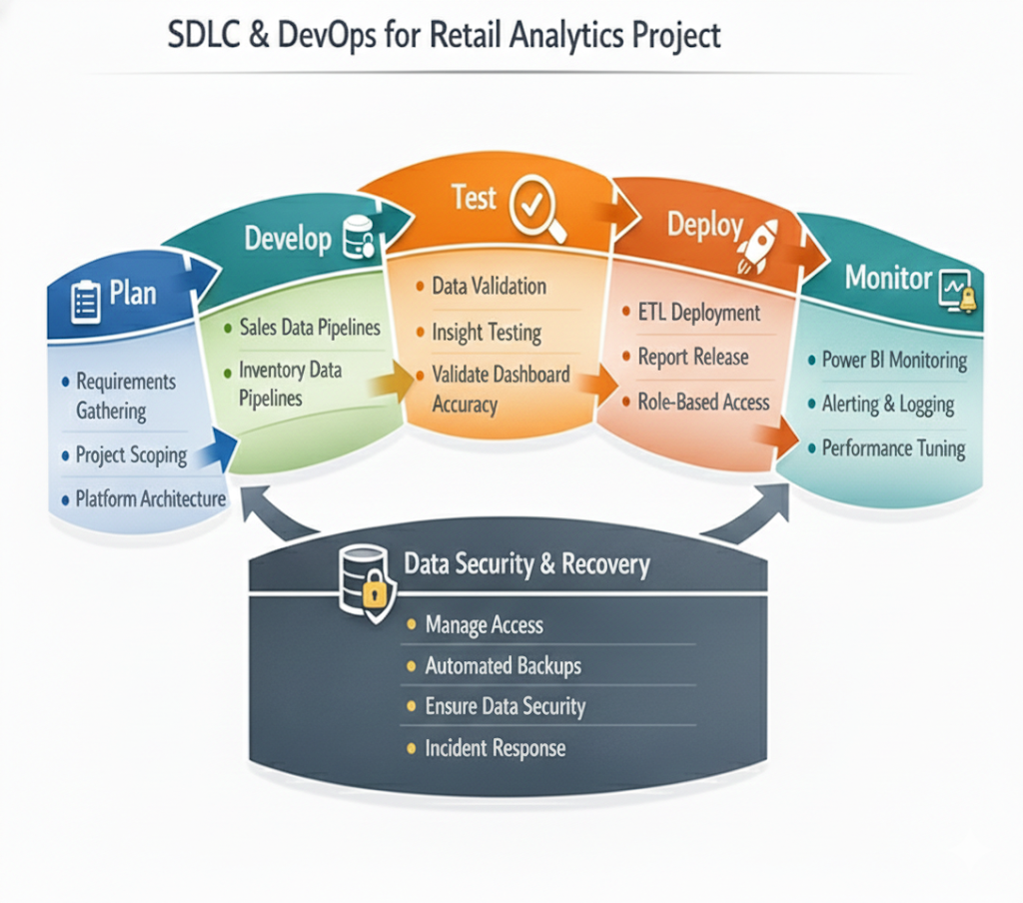
- Deployment Strategy
The solution is designed with scalability in mind and can be enhanced to support advanced analytics use cases.
Deployment includes:
- Configuration-driven deployments
- Approval gates for production releases
- Post-deployment validation checks
- Rollback mechanisms for failure scenarios
- Modules & Timeline
Weeks 1–2: Project Foundations & Planning
- Business requirement analysis for offline retail operations
- KPI identification (sales, inventory, customer metrics)
- Data source identification (POS, inventory, product, customer)
- High-level Azure architecture design
- Relational data model design

Weeks 3–5: Data Generation & Batch Ingestion (Raw Layer)
- Synthetic data generation using Python
- CSV / Excel / image metadata preparation
- ADF pipeline development
- Batch ingestion into ADLS Gen2 (Raw zone)
- Scheduling, retries, and monitoring setup

Weeks 6–8: Data Cleaning & Transformation
- Data cleansing and standardization
- Schema and datatype validation
- Business rule implementation
- Transformation into structured datasets
- Storage in Cleaned/Silver layer

Weeks 9–11: Curated Layer & KPI Logic
- Creation of analytics-ready Gold tables
- KPI calculations (sales, inventory, customer metrics)
- Aggregation and performance optimization
- KPI validation

Weeks 12–14: Analytics, Dashboards & UAT
- Power BI data model creation
- Dashboard development
- User Acceptance Testing (UAT)
- Feedback incorporation

Weeks 15–16: Go-Live & Knowledge Transfer
- Production deployment
- Monitoring and alert configuration
- Performance tuning and cost optimization
- Documentation and user training

- Risks, Assumptions & Dependencies
Risks:
- Incomplete or inconsistent POS data
- Data quality issues from manual entries
Assumptions:
- Batch data availability
- Stable source schemas
Dependencies:
- Store IT support
- POS and inventory system access
- Future Enhancements
The solution is designed with scalability in mind and can be enhanced to support advanced analytics use cases.
Future scope includes:
- Near real-time sales ingestion
- Customer segmentation using ML
- Demand forecasting and replenishment optimization
- Image-based product analytics
- Conclusion
The Offline Fashion Retail Analytics Platform delivers a scalable and structured solution for analyzing store operations, sales performance, inventory efficiency, and customer behavior. By integrating data from POS systems, inventory records, product catalogs, customer data, and unstructured image metadata, the platform establishes a single source of truth for retail analytics.
Built using Azure-native data engineering services, the solution emphasizes reliability, traceability, and maintainability. Azure Data Factory enables controlled batch ingestion, Azure Data Lake Storage Gen2 provides layered storage, and Azure Databricks handles scalable data transformation and business logic implementation.
Through curated KPIs and interactive Power BI dashboards, the platform empowers store managers and business leaders to make data-driven decisions that improve sales performance, reduce stockouts, and enhance customer experience. The design supports future expansion into real-time analytics and advanced machine learning, making it a strong foundation for enterprise retail analytics.

